Test Case: tc002_SPX_Dev5_Crear_Requisicion_Spot_Con_FAD_Tipo_Cobro_CC
Step 1 - Enter username and password and click to button Enter : Credentials Entered
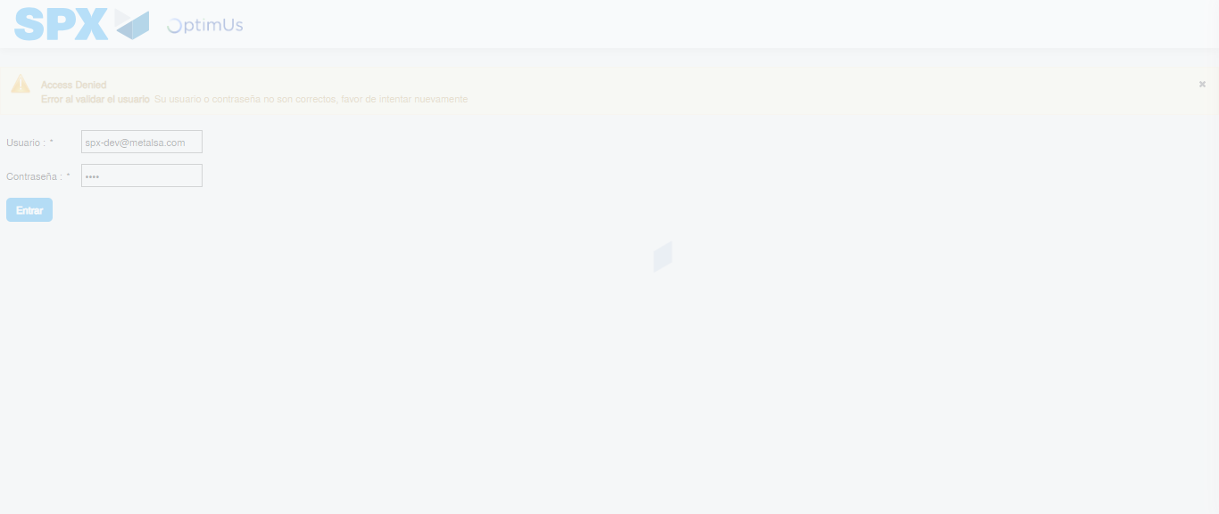Image file-name: QC_Testing-tc002_SPX_Dev5_Crear_Requisicion_Spot_Con_FAD_Tipo_Cobro_CC-1790175680453

Step 2 - Select to UEN and Access to Spot Buy Requisitions : UEN Correctly selected and Correct access
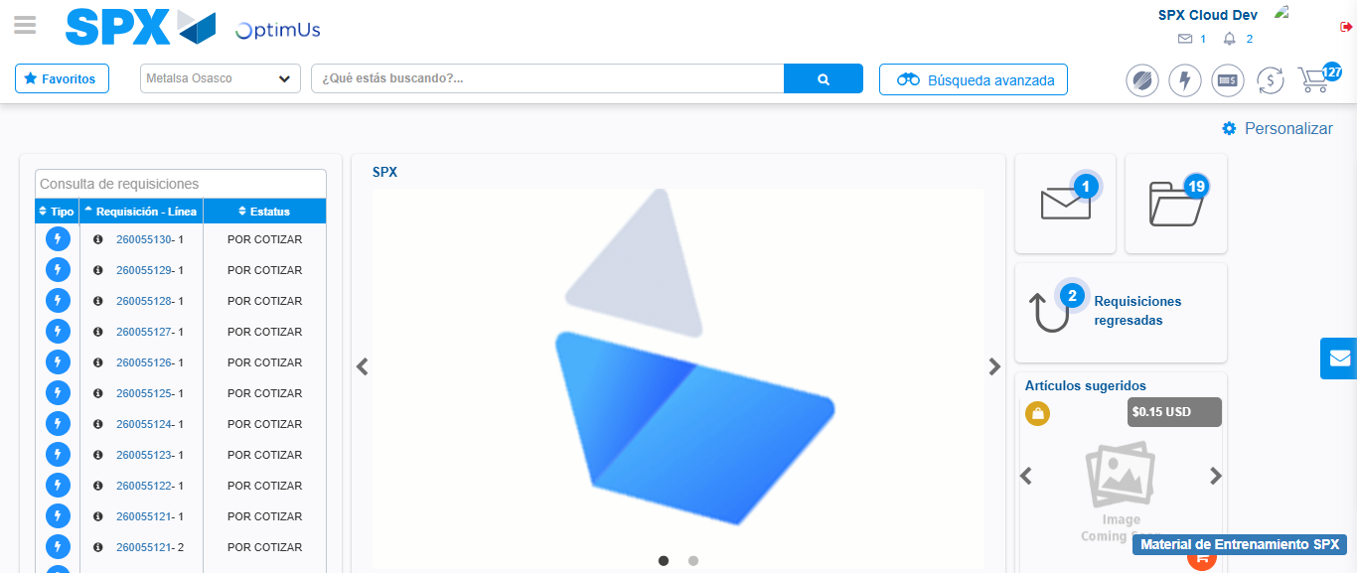Image file-name: QC_Testing-tc002_SPX_Dev5_Crear_Requisicion_Spot_Con_FAD_Tipo_Cobro_CC-1790175704297

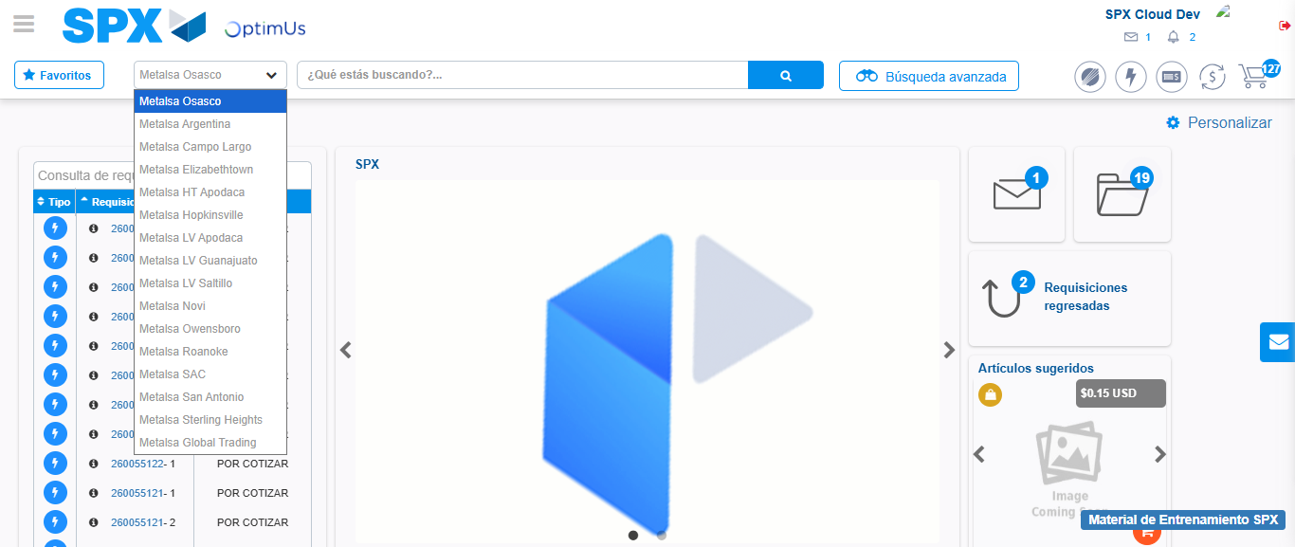Image file-name: QC_Testing-tc002_SPX_Dev5_Crear_Requisicion_Spot_Con_FAD_Tipo_Cobro_CC-1790175704756

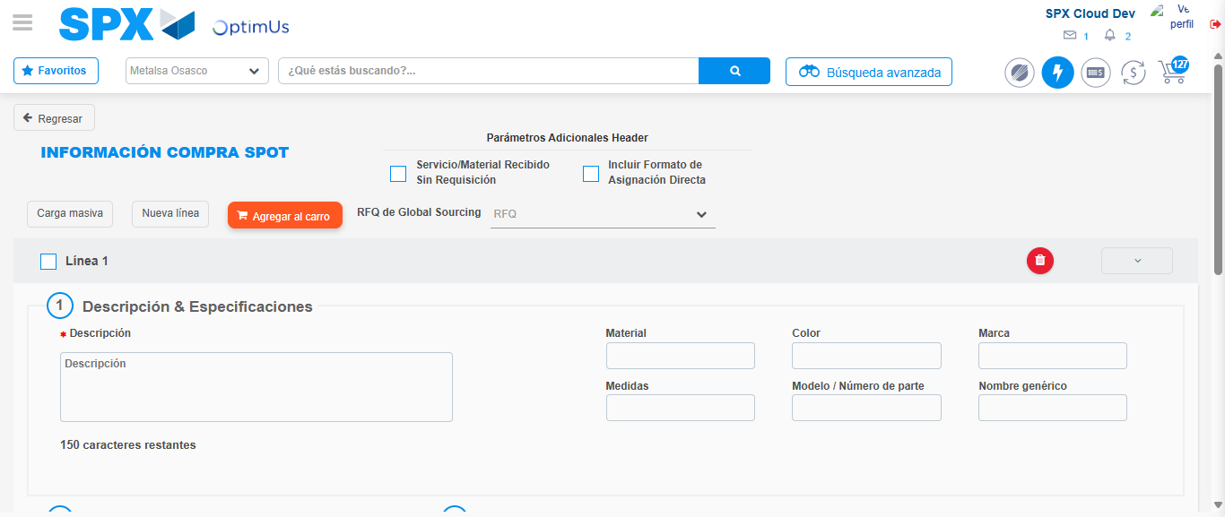Image file-name: QC_Testing-tc002_SPX_Dev5_Crear_Requisicion_Spot_Con_FAD_Tipo_Cobro_CC-1790175709508

Step 3 - Add FAD to Requisition: FAD Successfully Added
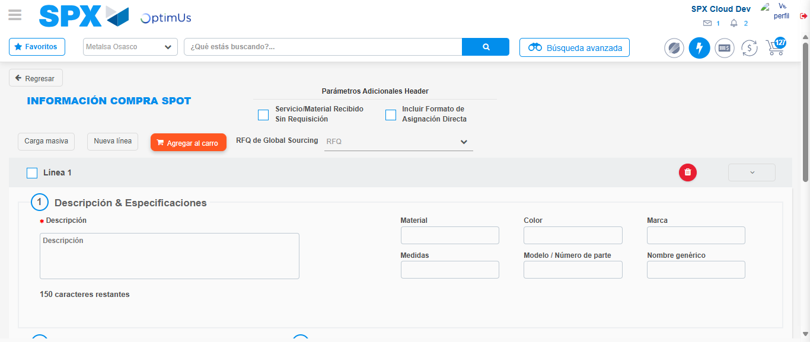Image file-name: QC_Testing-tc002_SPX_Dev5_Crear_Requisicion_Spot_Con_FAD_Tipo_Cobro_CC-1790175709731

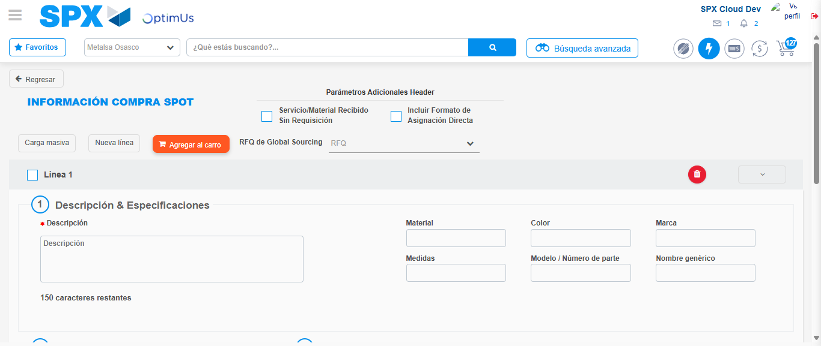Image file-name: QC_Testing-tc002_SPX_Dev5_Crear_Requisicion_Spot_Con_FAD_Tipo_Cobro_CC-1790175709887

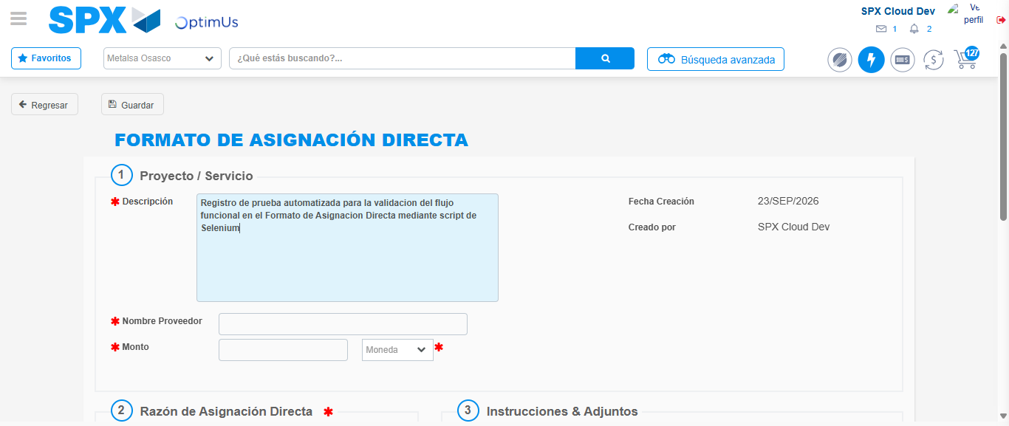Image file-name: QC_Testing-tc002_SPX_Dev5_Crear_Requisicion_Spot_Con_FAD_Tipo_Cobro_CC-1790175712546

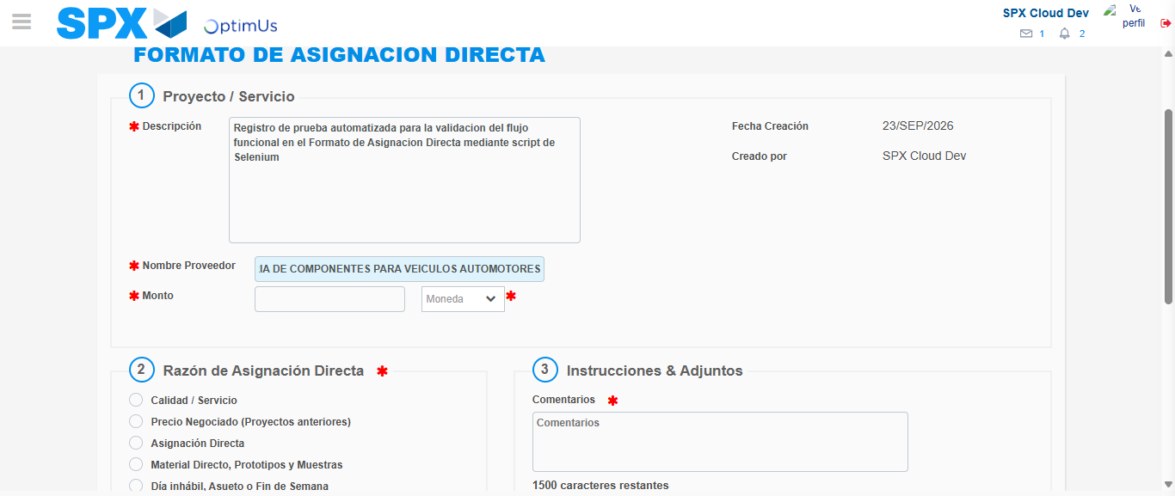Image file-name: QC_Testing-tc002_SPX_Dev5_Crear_Requisicion_Spot_Con_FAD_Tipo_Cobro_CC-1790175721435

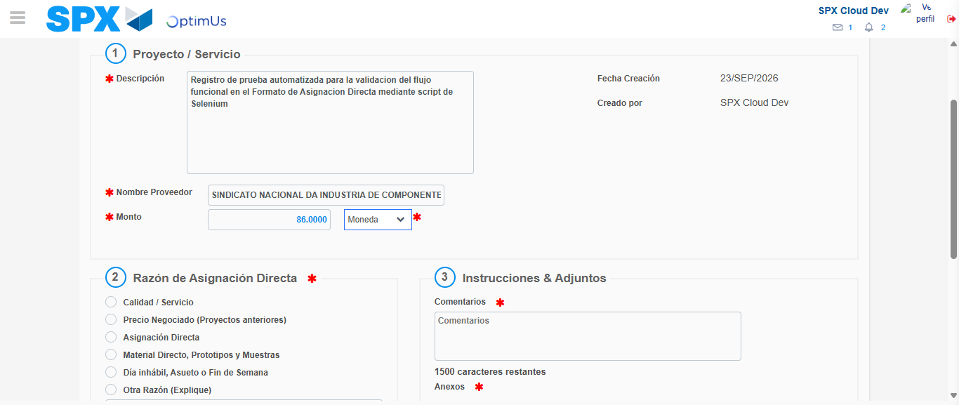Image file-name: QC_Testing-tc002_SPX_Dev5_Crear_Requisicion_Spot_Con_FAD_Tipo_Cobro_CC-1790175721754

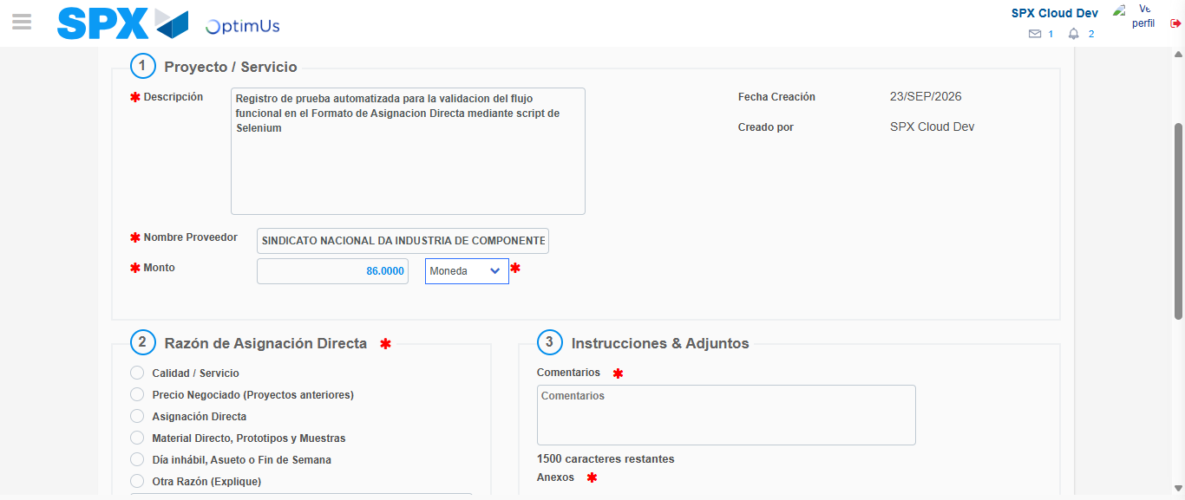Image file-name: QC_Testing-tc002_SPX_Dev5_Crear_Requisicion_Spot_Con_FAD_Tipo_Cobro_CC-1790175721916

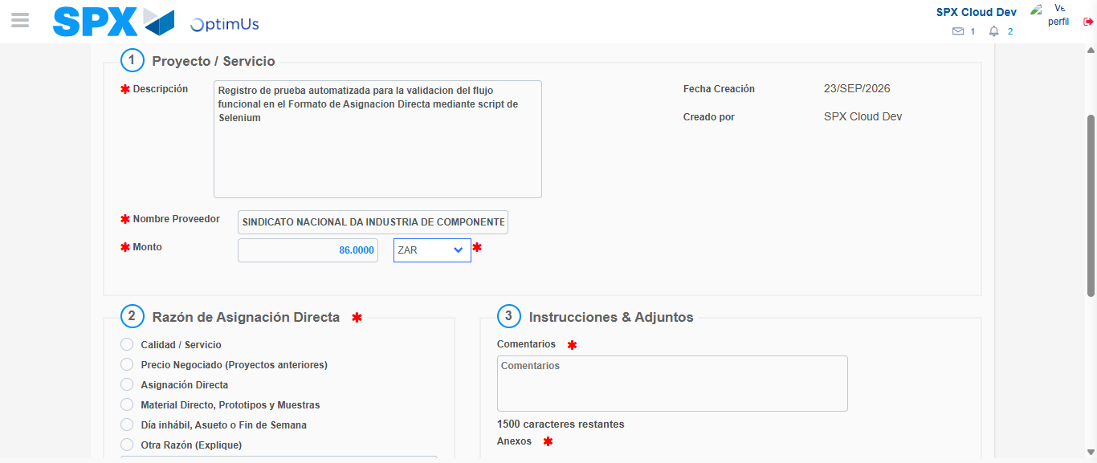Image file-name: QC_Testing-tc002_SPX_Dev5_Crear_Requisicion_Spot_Con_FAD_Tipo_Cobro_CC-1790175722229

Image file-name: QC_Testing-tc002_SPX_Dev5_Crear_Requisicion_Spot_Con_FAD_Tipo_Cobro_CC-1790175722390

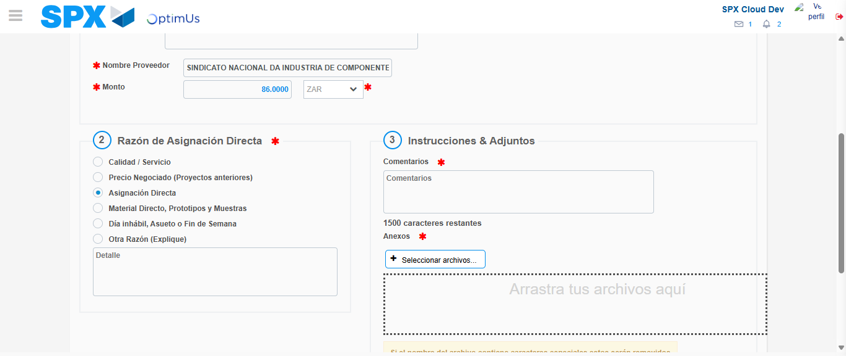Image file-name: QC_Testing-tc002_SPX_Dev5_Crear_Requisicion_Spot_Con_FAD_Tipo_Cobro_CC-1790175723159

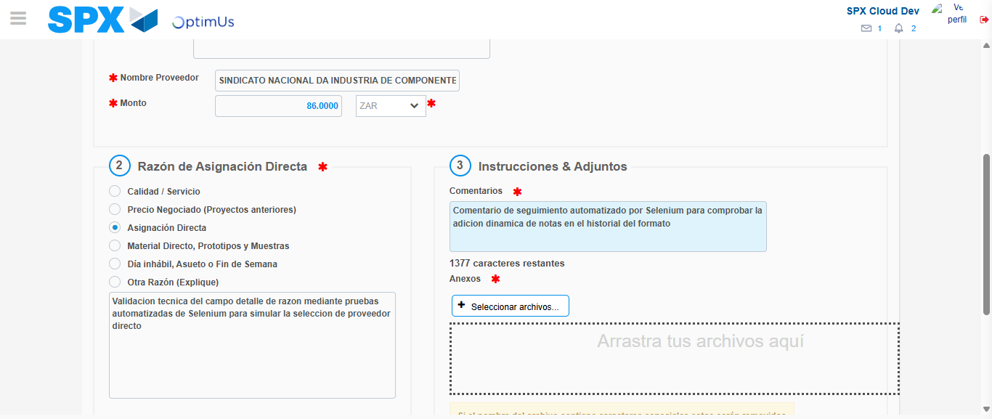Image file-name: QC_Testing-tc002_SPX_Dev5_Crear_Requisicion_Spot_Con_FAD_Tipo_Cobro_CC-1790175734178

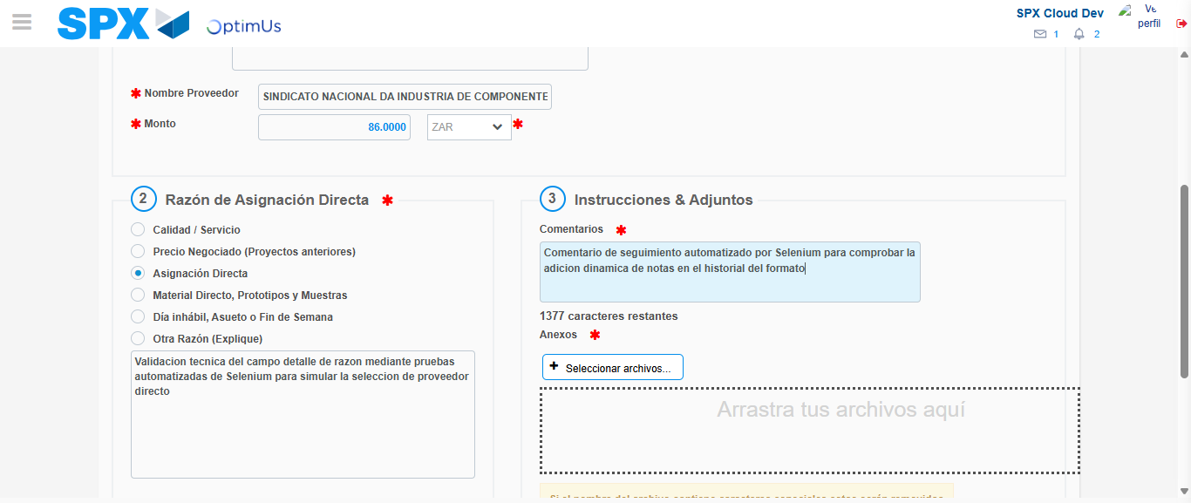Image file-name: QC_Testing-tc002_SPX_Dev5_Crear_Requisicion_Spot_Con_FAD_Tipo_Cobro_CC-1790175734708

Step 4 - Data Capture Spot Buy Requisition: Data captured correctly
Image file-name: QC_Testing-tc002_SPX_Dev5_Crear_Requisicion_Spot_Con_FAD_Tipo_Cobro_CC-1790175709731

Image file-name: QC_Testing-tc002_SPX_Dev5_Crear_Requisicion_Spot_Con_FAD_Tipo_Cobro_CC-1790175709887

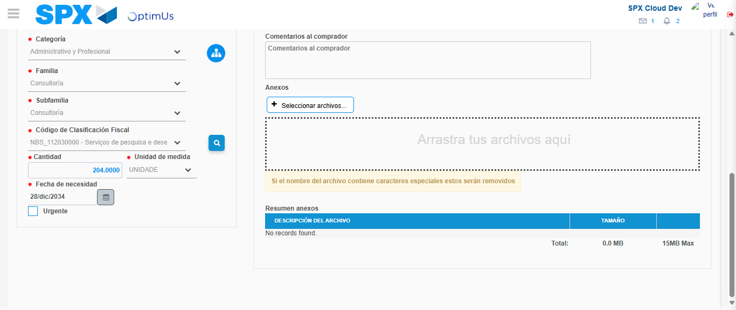Image file-name: QC_Testing-tc002_SPX_Dev5_Crear_Requisicion_Spot_Con_FAD_Tipo_Cobro_CC-1790175752101

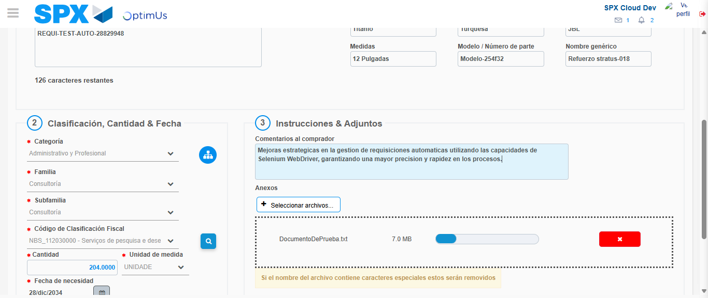Image file-name: QC_Testing-tc002_SPX_Dev5_Crear_Requisicion_Spot_Con_FAD_Tipo_Cobro_CC-1790175752864

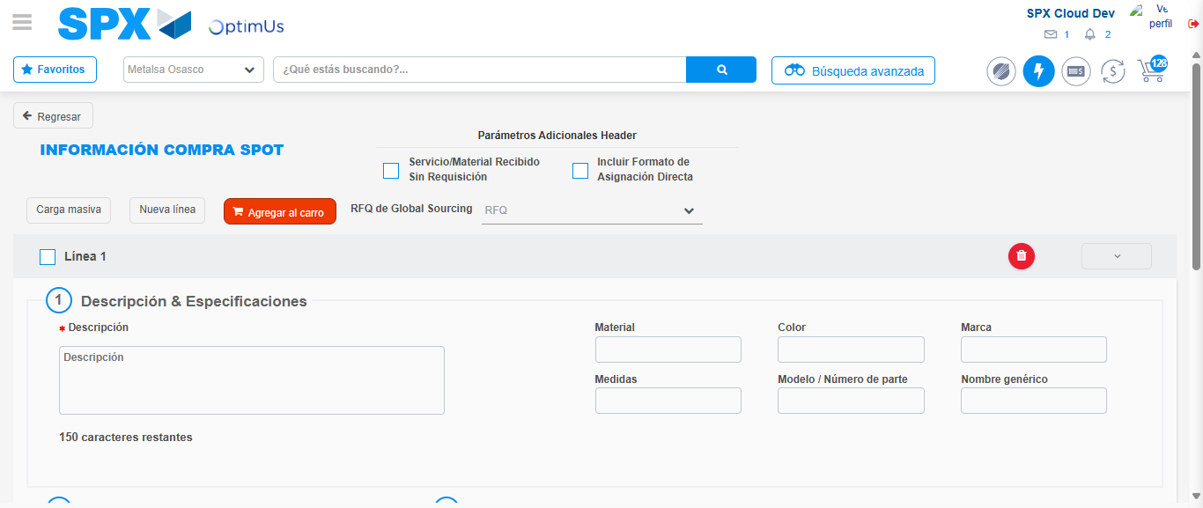Image file-name: QC_Testing-tc002_SPX_Dev5_Crear_Requisicion_Spot_Con_FAD_Tipo_Cobro_CC-1790175768579

Step 8 - Return to Main Page SPX : Return to Main Page SPX
Image file-name: QC_Testing-tc002_SPX_Dev5_Crear_Requisicion_Spot_Con_FAD_Tipo_Cobro_CC-1790175704297

Image file-name: QC_Testing-tc002_SPX_Dev5_Crear_Requisicion_Spot_Con_FAD_Tipo_Cobro_CC-1790175704756

Image file-name: QC_Testing-tc002_SPX_Dev5_Crear_Requisicion_Spot_Con_FAD_Tipo_Cobro_CC-1790175709508

Image file-name: QC_Testing-tc002_SPX_Dev5_Crear_Requisicion_Spot_Con_FAD_Tipo_Cobro_CC-1790175770750

Image file-name: QC_Testing-tc002_SPX_Dev5_Crear_Requisicion_Spot_Con_FAD_Tipo_Cobro_CC-1790175770872

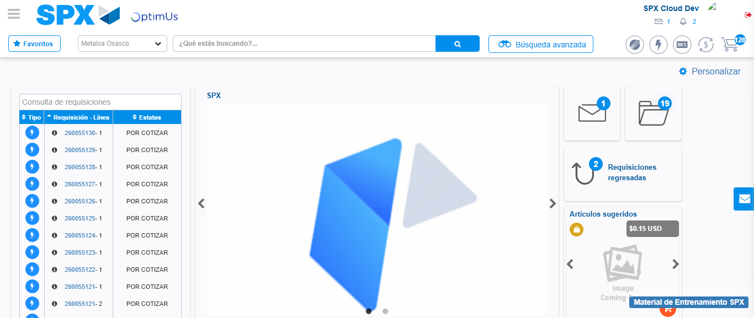Image file-name: QC_Testing-tc002_SPX_Dev5_Crear_Requisicion_Spot_Con_FAD_Tipo_Cobro_CC-1790175792300

Step 9 - Log Out : Log Out SPX
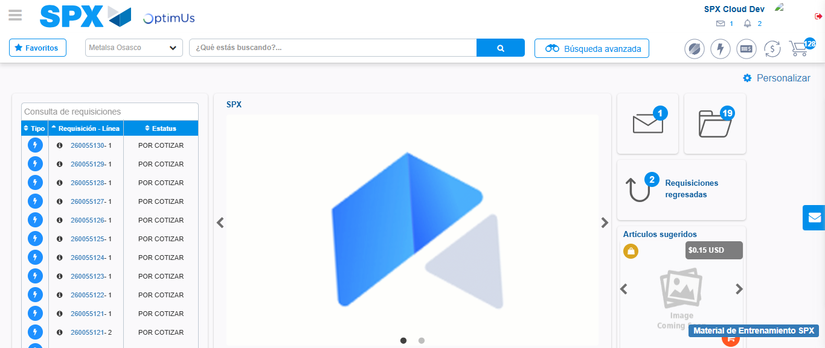Image file-name: QC_Testing-tc002_SPX_Dev5_Crear_Requisicion_Spot_Con_FAD_Tipo_Cobro_CC-1790175792524

